Assignment 11.1 – Flume

In the below location the twitter data will be moved accordingly

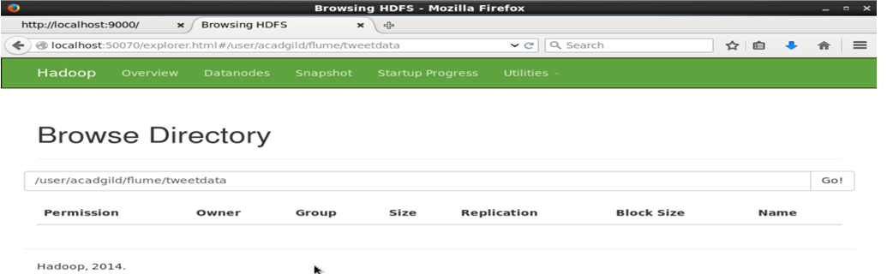

Command to run the agent for Twitter data streaming.

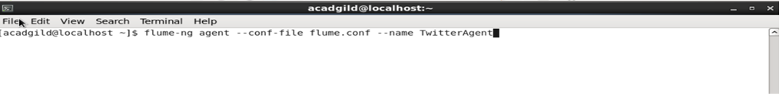

While processing the it taken the screen print

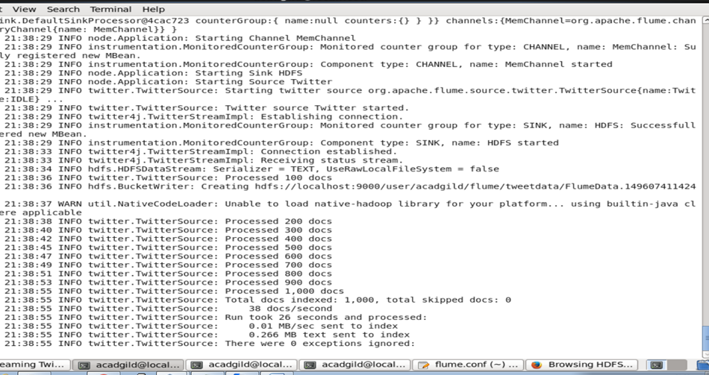

http://localhost:9000/user/acadgild/flume/tweetdata

Finally twitter data got stored in the above mentioned path

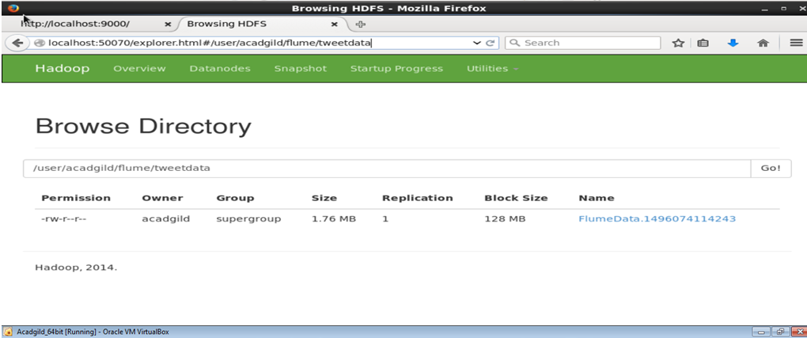

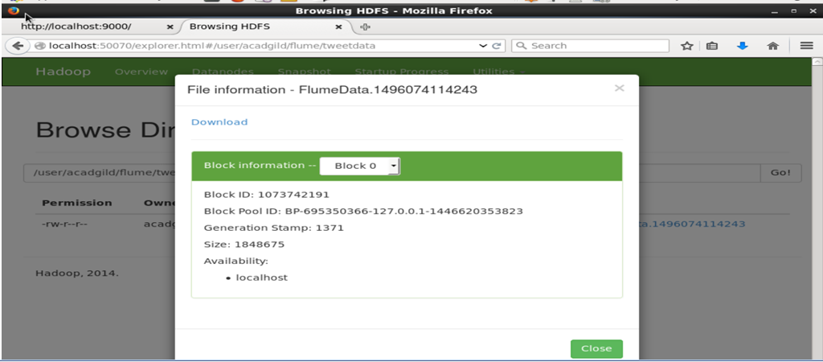

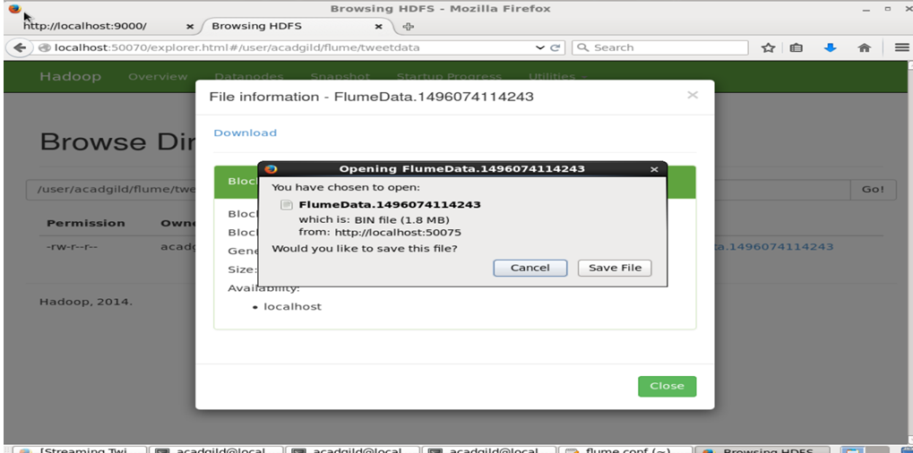

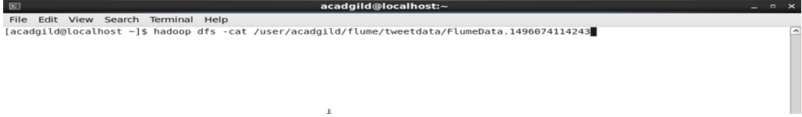

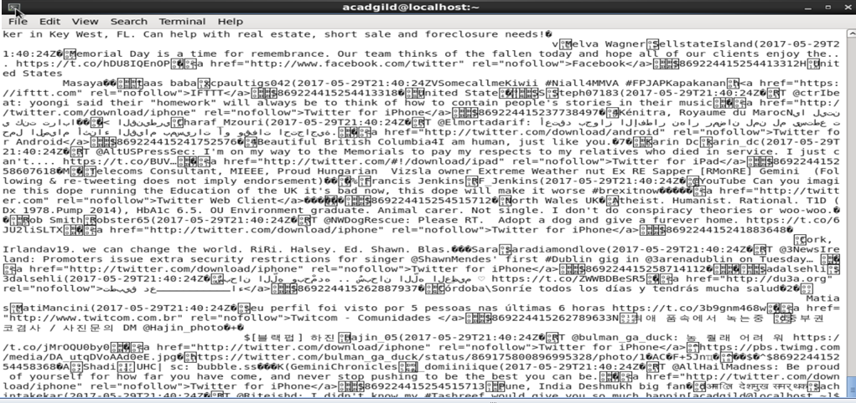

Agent details are below

